- Its inhibit biosynthesis of Nucleic Acid NA(inhibition of DNA/ RNA synthesis).  
* There are compounds that prevent the biosynthesis and utilization of normal cellular metabolites.

- BLOCK NA biosynthesis(DNA/RNA), also called enzyme inhibitor.  
 ؞ Cell cycle specific agents( CCSA) with activity in the S phase.

The antimetabolite drugs may exert their effects by several individual mechanisms involving:-

1. Enzyme inhibition at active.
2. Enzyme inhibition at allosteric.
3. Enzyme inhibition at related sites.

Most of these targeted enzymes and processes are involved in regulatory steps of cell division and cell/tissue growth.Often the administrated drug as prodrug , that required activation in vivo to yield the active inhibitor.

The administration of many purine and pyrimidine antimetabolites requires the formation nucleoside and finally the corresponding nucleotide for antimetabolite activity .

Classification of antimetabolites:

a. Purine antagonists inhibit AMP and GMP synthesis.

b. Pyrimidine antagonists inhibit synthesis of pyrimidine nucleotides ( especially TMP).

c. Folic acid antagonist, inhibit thymidine synthetase.

Purine antagonists, inhibit the synthesis of Purine-based nucleotides Adenosine monophosphate(AMP) and Guanosine monophosphate (GMP).

Pyrimidine antagonists, stop the production of the pyrimidine-based nucleotides, primarily deoxythymidine monophosphate (dTMP).

Purine Antagonists:

Which include, inhibit synthesis of AMP (Adenylic) and GMP (guanylic) through the following steps:-

1. Inhibit the conversion of 5-phosphoribosyl pyrophosphate into 5-

Phosphoribosylamine through using Amidophosphoribosyl

transferase inhibitors(which is a major target for antimetabolite

drugs) .

2. Inhibit conversion of inosinic acid to adenylsuccinic acid.

3. Inhibit conversion of adenylsuccinic acid to AMP.

4. Inhibit conversion of inosinic acid to xanthylic acid.

Purine drugs:

Which include purine biosynthesis inhibitors, such as 6-Mercaptopurine (6-MP).

Design of antimetabolite based on purine structure began with isosteric thiol/sulfahydryl group to replace 6-hypoxanthine, this purine requires bioactivation to its ribonucleotidee,6-thioinosinate(6-MPMP) by enzyme hypoxanthine guanine phosphoribosyl transferase(HGPRT).

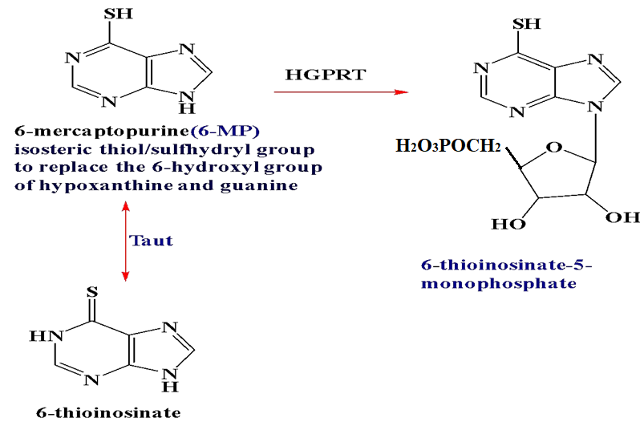

**- Is a potent inhibitor of an early step in basic purine biosynthesis, the conversion of 5-phoephoribosylpyrophosphate into 5-phosphoribosylamine.**

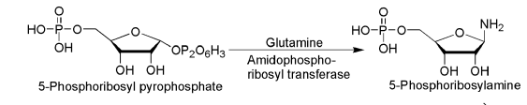

- the ribose diphosphate and triphosphate of 6-mercaptopurine are active enzyme inhibitors and the triphosphate can be incorporated into DNA & RNA to inhibit chain enolation.



**Thioguanine (6-Thioguanine = 6-TG)**

**-** It analogous to 6-MP.

- Thioguanine is coverted into its ribonucleotide by the same enzyme that act on 6-MP. It is converted further in to Diphosphate & then triphosphates, these species inhibit most of the same enzymes that are inhibite by 6-MP.

* Thioguanine is also incorporated into RNA, and it’s 2⁻-deoxy metabolite is incorporated into DNA. So, after incorporated into RNA & DNA and subsequent disruption of polymers may account for a greater portion of the antineoplastic activity of Thioguanine.

Drug resistance in certain cell lines may be caused by lower activity of activating enzymes or higher activity of catabolic enzymes.

For the classic purine antimetabolite , 6-MP major pathways of inactivation include S-methylation via tiopurine-S-methyl transferase (TPMT) ,and oxidation by enzyme Xanthine oxidase (XO) .

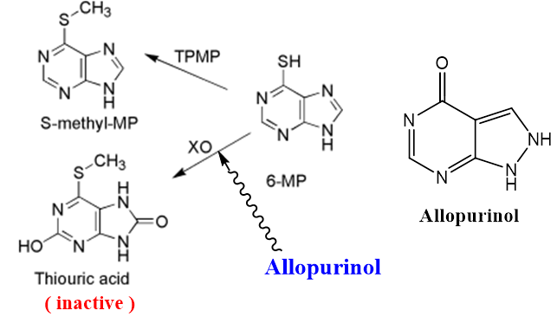

- XO enzyme ,converts the drugs to the inactive thiouric acid and inhibition of enzymes that responsible for the catabolic breakdown of the purine drugs can potentiate the drugs antineoplastic activity.

Allopurinol, its potent inhibitor of xanthine oxidase and is often used as adjuvant in purine anticancer therapy.

Allopurinol is increase both the potency and the toxicity of 6-MP.

Its play importance role, its prevents the uric acid kidney toxicity cause by the release of purines from destroyed cancer cell.

Development heterocyclic derivatives of 6-MP, Azathioprine

Azothioprine were designed to protect it from catabolic

reactions. Although, Azathioprine has antitumor activity,

it is not significantly better than 6-MP. It has an important

role, as an immunosuppressive agent in organ transplants.

**Adenine arabinoside (Vidarabine):**



*It contain sugar (D-arabinose) ,which is Epimeric with

D-ribose at 2⁻- position.

* it a competitive DNA polymerase – I .

-Act as antiviral effect than as antineoplastic activity.

* So, most Adenine arabinoside & some its derivatives

are limited in antitumor effected by susceptibility to

adenosine deaminase. This enzyme converts them to

inactive hypoxanthine arabinoside derivatives . high levels of adenosine deaminase accounts for resistant of certain tumors to action of adenine arabinoside.



* Addition of Fluorine to sugar moiety has produced some purine-based drugs drugs with resistance to the catabolic activity of adenosine deaminase.

**- Incontrast** to the susceptibility of adenosine arabinoside to adenosine deaminase,its 2-fluro derivative, Fludarabine, is stable to this enzyme, and its activity as antineoplastic depends on its anabolic conversion to the corresponding triphosphate-2-chloro-2-deoxyadenosine(Cladribine) also is resistant to adenosine deaminase. It is phosphorylated in cells to the triphosphate by cytidine kinase, and the triphosphate inhibits enzymes required for DNA repair.

